Facial recognition

Software

1. Problems to be solved
2. Further improvement
3. Benefits of the software
4. Steps followed (WITH PICS)

**PROBLEMS TO BE SOLVED**

Crimes done in shopping centers, bus stands, highways and unrestricted areas like greens. This can help in reducing crimes as it recognize faces in public for the person we are looking for because only the police department has the picture of the missing or wanted person. When people will download the software the person who has the picture will be upload on it. It will automatically detect the face of that person found anywhere in CCTV surveillance. As we all know it is used in mobile phones to unlock the passwords. Face recognition has the ability to make advertising more targeted by making educated guesses at people’s age and gender. Facial recognition can aid forensic investigations by automatically recognizing individuals in security footage or other videos Face recognition surveillance systems can instantly identify when expelled students, dangerous parents, drug dealers or other individuals that pose a threat to school safety enter school grounds. By alerting school security guards in real time, face recognition can reduce the risk of violent acts.

**Further improvement**

This software can sometimes fail in recognizing face when a person has covered his face. So, we will try to improve this. We have to add pics of the staff one by one which is time consuming but we will find the solution for this also.

**Benefits of this software**

The criminals can be found easily in CCTV surveillance. Sometimes missing person can also be found using this software. . Companies like Tesco are already planning on installing screens at gas stations with face recognition built in. It’s only a matter of time before face-recognition becomes an omni-present advertising technology. Face recognition can be used to find missing children and victims of human trafficking. As long as missing individuals are added to a database, law enforcement can become alerted as soon as they are recognized by face recognition—be it an airport, retail store or other public space. In fact, 3000 missing children were discovered in just four days using face recognition in India. . Face recognition software can also be used to identify dead or unconscious individuals at crime scenes. Facebook uses face recognition technology to automatically recognize when Facebook members appear in photos.

**Steps followed**

This software removes everything accept faces. This makes it easier for people to find photos they are in and can suggest when particular people should be tagged in photos. This will store the data in numbers. It can reduce image from 4000 to 39 specific pictures. It focuses on the features of a person.

**STEPS**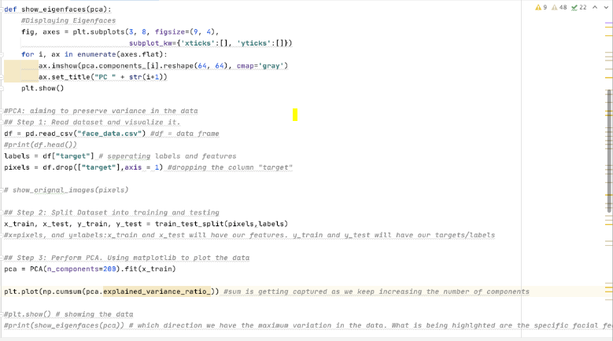

***BCM ARYA MODEL SE. SEC. SCHOOL***

***SHASTRI NAGAR, LUDHIANA***

***SATYAM ROLL NO 38 CLASS 8THA***